Shawnee Community College
Athletic Manual
August 2020

SAINTS PRIDE

W

elcome to Shawnee Community College and the Saints Intercollegiate Athletic Program!

Our goal is to afford your student the opportunity to find both success and enjoyment in his/her academic, social, and athletic pursuits.

We achieve this goal by striving for excellence. Excellence means:
- An insistence that athletes are students first, with graduation rates that compare favorably to other full-time, degree-seeking students.
- Participation in a range of sports with balance between men's and women's sports.
- Teams that are well-coached, competitive, and representative of high standards and personal conduct.

Shawnee Community College is a member of the National Junior College Athletic Association (NJCAA) and Illinois Region 24.

We are the athletic teams and individuals that represent Shawnee Community College and the communities of the counties in our district. We expect each student to maintain a high-quality profile. We do not expect our athletes to be involved in profanity, drinking, or the use of illegal drugs. We do not expect our athletes to infringe on the rights of other people. Fighting is simply not acceptable conduct. The Athletic Director will take action against any individual not meeting College standards, depending on the recommendation of the coach of the sport in which that individual participates and/or the severity of the offense. If the Athletic Director so deems, the discipline may include suspension from the team up to expulsion from intercollegiate athletic participation.

TABLE OF CONTENTS

ATTENDANCE 4

CODE OF CONDUCT 4

ADVISING 5

DROPPING COURSES 6

ELIGIBILITY AND ENROLLMENT 6

EQUIPMENT 6

EXIT CHECKLIST 6

FINANCIAL AID 7

FUNDRAISING 7

INSURANCE 7

PHYSICALS 8

PRIVACY ACT 9

SEXUAL HARASSMENT 9

STUDENT WORK 10

SUBSTANCE ABUSE PREVENTION PROCEDURES 10

ATHLETIC CHECKLIST 14

AUTHORIZATION TO RELEASE INFORMATION 15

PHYSICAL EXAMINATION FORM 16

PHYSICAL HISTORY FORM 17

ATHLETE WITH SPECIAL NEEDS SUPPLEMENTAL HISTORY FORM 18

PHYSICAL EVALUATION CLEARANCE FORM 19

DRUG TEST CONSENT FORM 20

ACKNOWLEDGMENT AND AGREEMENT OF ATHLETIC PROCEDURE MANUAL 23

ATTENDANCE
All Athletes are expected to be present for all assigned classes, lectures, or laboratory sessions. If you are absent, you must show your instructor that your absence has been for a good cause. If you are absent more times during the semester than the number of times the class meets per week, you may be dropped from the course at the discretion of the instructor. When an instructor drops a student with an effective date before the midterm date of the class, a "W" will be recorded. When an instructor drops a student with an effective date after the midterm date, the instructor will have the prerogative to assign a grade of "F."

Absence due to approved College business (games/matches) will result in no direct absence penalties. Although your instructor may excuse your absence, you are still responsible for completing all of the work in the course to the satisfaction of the instructor.

CODE OF CONDUCT
Students at Shawnee College have the same rights as those accorded all citizens of the United States and the State of Illinois, including the right to free, open and responsible discussion and inquiry and the right to quality education in a program of study under competent instructors.

The College is obligated to the people of the district and the State to provide an environment that is conducive to the academic and personal development of its students. This obligation requires the College to conduct its affairs in an orderly, uninterrupted manner.

Rules of the community govern student conduct on Campus and at all College-sponsored activities. Violations of federal, state, and local laws at any College-sponsored activity, on or off-campus, will be considered a violation of the Student Conduct Code, and violators will be subject to disciplinary actions. Such violations include but are not limited to:

- acts that interfere with the purpose, necessities, and processes of the College community or that deny the rights of members of the College community;
- denying a trustee, employee, student, or invitee of the College freedom of movement or use of the facility;
- disrupting the performances of institutional duties or pursuit of educational activities;
- occupying buildings or other property after due and legal notice to depart;
- causing or threatening to cause harm to an individual either directly or indirectly by action or verbal behavior;
- academic misconduct including, but not limited to, cheating, plagiarism, and forgery;
- sexual harassment. Sexual harassment is defined as any unwelcome attention of a sexual nature that creates an intimidating, hostile, or offensive environment or that interferes with educational or work performance. Sexual harassment is a violation of state and federal law as well as Shawnee College's policy;
- otherwise, improper language, loitering, or assembling; creating any hazard to person or things: blocking access ways; improper disposal of rubbish, and lewd or obscene conduct as defined by law;
- possession and/ or consumption of alcoholic beverages except at off-campus activities where such possession and consumption meet requirements of state law and where the location of the activity does not prohibit such drinks;
- sale, use, possession, or distribution of marijuana or possession of any controlled substance not prescribed by a licensed physician;
- illegal gambling;
- theft or damage to College property or property of a member of the College community;
- failure to meet financial obligations relative to College transactions or the issuing of fraudulent checks;
- the possession of explosives, firecrackers, firearms, dangerous chemicals, or other weapons except as specially permitted by law and College officials;
- giving false or misleading information in response to requests from College officials

Academic misconduct includes plagiarism, cheating, failure, or refusal to follow clinical practice standards, and soliciting, aiding, abetting, concealing, or attempting such acts.

Plagiarism is defined as the act of representing the work of another as one's own. Plagiarism may consist of copying, paraphrasing, or otherwise using written or oral work of another without proper acknowledgment of the source or presenting oral or written material prepared by another as one's own.

For a full discussion of the Student Rights and Conduct Code, please refer to the Shawnee Community College Student Handbook.

-Disciplinary Action-
A. Any violation of the Code of Conduct shall be referred for action to the appropriate Vice President.

B. It is within the power of the President of Shawnee College or his designated representative to suspend
students from the College for violation of local, state, or school policy.

C. The Student-Athlete Manual and scholarship form describe the student's responsibility as a member of
the athletic team. Failure to meet these standards is grounds for action by the Coach or Athletic
Director.

-Community Conduct-
Community conduct will be handled by the Athletic Director, Vice President, and Head Coach. Penalties can be light or as severe as expulsion from the team, depending on the infraction. Conduct unbecoming of an athlete or detrimental to the image of Shawnee Community College is subject to immediate cancellation of the scholarship agreement.

-Game Discipline-
Game discipline will be handled by the coach and will include a memo to the Athletic Director on any incident where discipline is deemed necessary. NJCAA rules will be followed in terms of game conduct in which officials have levied sanctions.

The individual sports coaches or Athletic Director can sanction rules that are stricter than the College's Code of Conduct. These rules will be provided in writing at the beginning of each sport's
season. At no time will any rules from individual sports teams be less than those of the Athletic Director or College Code of Conduct.

Termination of the scholarship agreement is possible if the Student Code of Conduct is not followed.

ADVISING
All students should register as soon as possible to ensure enrollment in the desired classes. The College Advisors will aid students in academic advancement. We strongly recommend that athletes take 16 hours per semester to keep them on "track" for graduation. Advising also acts as an "eligibility buffer" if the student should need to drop a class. Students must maintain a 2.0 GPA to receive credit for a certificate program. Personal counseling and free tutoring are offered in the Counseling Center and the Student Success Center.

Students who encounter problems in the classroom have available to them the Student Success Center. The Success Center has both professional and peer tutors available in most subject areas. We strongly encourage the student-athletes to use the Success Center if problems are occurring in certain subjects.

DROPPING COURSES
It is the student's responsibility to withdraw from classes when not in attendance. Failure to withdraw properly could result in a failing grade. Please note: Instructors can assign a W (Withdrawn) or WF (Withdrawn Failing) grade before the published last date to withdraw from a class. An official "Drop/Add/Section Change "form must be completed and signed by students (and coach) wishing to be removed from a class.

WITHDRAWAL
The responsibility for withdrawing from a class rests with the student. The student must abide by the following provisions:
- Contact a member of the counseling staff to initiate a drop from the course.
- After the first day of instruction, the student must take the withdrawal slip, obtain the instructor's initials, and deliver this form to the Admissions and Advisement office to be officially withdrawn from class.
- The date of withdrawal will be the date the Advisor receives the form.
- Not attending class does not constitute a withdrawal from class. Failure to officially withdraw by the academic penalty date will result in a failing grade for the semester.

Note: Please consult the Official College Calendar for the final drop dates each semester.

ELIGIBILITY AND ENROLLMENT
All athletes must enroll in and maintain a minimum of 12 credit hours, as stated in the NJCAA Rules and Regulations. Athletes become ineligible the moment they drop below twelve hours. The Shawnee Community College Athletic Department expects all athletes to enroll in 16 hours per semester.

Official transcripts (high school and all post-secondary work) are processed in the Registrar's Office. They must be in before the first scheduled game, or the student will not be eligible to participate in any sport.

If transcripts are brought in by the student, they must be in a sealed envelope. Official transcripts must be in before eligibility can be certified. Those students who have been out of college or high school for a while (beyond regular summer term) must submit, to the Athletic Director, a delayed enrollment statement. This statement is a summary of what the student has been doing in the time spent out of school. The statement should include the employer's name, address, and phone number (if available) along with specific time frames or work and whether the job was full or part-time.

EQUIPMENT
All assigned equipment must be turned in after the sports season. Any athlete not turning in gear will have transcripts placed on restriction until equipment is returned or payment for replacement of the equipment is received in the Athletic Office.

EXIT CHECKLIST
Any athlete who has been released/quit the team for any purpose during the academic year must complete an exit checklist. This process informs the student-athlete of mandatory responsibilities that need to be completed to finish or withdraw from the current school term and helps facilitate the smooth transition in transferring to other colleges or continuing education at Shawnee Community College.
FINANCIAL AID
All student-athletes must apply for financial aid using the Free Application for Federal Student Aid (FAFSA). All athletes receiving a scholarship award must fill out the Tuition Award form as well as apply for State and Federal Aid (ISAC/Pell Grant).

Student-athletes receiving a Pell Grant, Federal Work-Study, or College Work-Study must maintain a 2.0 GPA and be progressing toward a degree. If in any semester, they fall below a 2.0 GPA, they will be placed on Financial Aid Probation. Two semesters in a row under a 2.0 GPA, as calculated by the Admissions Office, warrant Financial Aid Suspension. The student will not be eligible to receive financial aid other than an athletic scholarship. The athlete may or may not remain eligible to participate in sports based on NJCAA academic requirements, which can be different than the College's requirements.

*Scholarship Athletes: All athletes who have received any form of the scholarship must have the following items completed and on file in the Athletic Office before they will be certified eligible to participate in their sport:
- NJCAA National Letter of Intent/Scholarship Form
- Athletic Scholarship Agreement Form
- Free Application for Federal Student Aid (FAFSA) form
- Insurance Information Form
- Consent to Release Information form
- Acknowledgment of understanding of Substance Abuse Prevention Procedures form
- Official High School and College transcripts

See the Athletic checklist on page 14.

All athletes receiving a book scholarship must turn in the books purchased with the scholarship after the semester. Students failing to return the books will have a hold placed on their transcript until the books are returned, or payment is made. The Bookstore will need a $100 deposit, and the student will forfeit the $100 if books are not returned or are late.

*Any student placed on restriction will be unable to register for the next semester's classes or have transcripts sent to other colleges or educational institutions until the restriction has been lifted.

FUNDRAISING
All fundraising will be done on behalf of Shawnee Community College. Profits from fundraising campaigns will be used to supplement athletic programs regardless of whether individuals involved in the fundraiser participate in the activity or not.

INSURANCE
Secondary Insurance Coverage is provided for athletes through the College. Each athlete must complete an Insurance Information Form before the first practice. All athletes participating in sports at SCC must have the form on file in the Athletic Office before participating in any practices, exhibition games, or intercollegiate contests.

Injuries do occur, and we attempt to provide our athletes with the very best possible care. Medical bills are incurred when the athlete is treated, whether it be locally, during a road trip, or by a medical vendor in his/her home area.

The NJCAA/NCAA does not permit us or any college or university to provide coverage or pay the bills incurred for expenses related to illnesses or conditions that are not sustained as the direct result of an accident in our intercollegiate sports program. This includes pre-existing conditions and non-athletic injuries. Chronic conditions developed over a long time and aggravated by participation in sports activities will not be covered.

The athletic accident insurance at Shawnee College provides secondary insurance coverage for athletes for accidents/injuries while participating in the play or official practice of intercollegiate sports.

All medical bills for athletes incurred as the result of any injury in the intercollegiate sports program will be sent directly to said athletes or their home address unless the College has instructed the medical vendors otherwise. In some cases, the athletic department may get a copy of the bill, but in no case will the athletic department be the primary place for the bill incurred to be sent.

When a bill is received, the following steps should be taken:

- Submit the bills incurred to the athlete's family plan or employer group coverage plan first.
The plan administrator will do one of two things:
- Honor the claim and pay all or a portion of the bills incurred.
- Not honor the claim and send an athlete a letter of denial. An example might be that athlete is no longer part of group policy after having attained the age of twenty-six.

- If there remains a balance after family, employer group insurance, or plan has contributed toward the claim, send the claim sheet from the insurance company and a copy of the itemized bills incurred to the College's athletic department.

If an athlete received a letter of denial from the family's group insurance plan administrator, send the letter of denial and a copy of the bills incurred to the College's athletic department. If no coverage, a letter from your employer with verification will be necessary.

- Once the Athletic Office receives the bills and claim form, they will be forwarded to our insurance carrier office for processing. If they need any additional information, please cooperate with them, and they will process the claim in the least possible amount of time.

- Medical bills will only be paid up to one year (52 weeks) from the date of injury. Prompt attention is necessary for all expenses incurred due to injury.

HMO or PPO
If the primary family coverage is through a Health Maintenance Organization (HMO) or Preferred Provider Organization (PPO), you must follow the proper procedures required by your plan for the College's insurance to complete its portion of the claim satisfactorily. Following the proper procedures are especially important if your plan requires pre-authorization to have your son/daughter treated if the medical facility is out of your plans service area.

PHYSICALS
All athletes are required to have a physical examination before the first practice. Athletes will not be permitted to participate in their sport until they have a physical on file in the Athletic Office.

PRIVACY ACT
The Family Educational Rights and Privacy Act of 1974 is a federal law that, among other things, stipulates that each educational institution must develop policies and procedures to ensure compliance with the act.

SCC is concerned that all students are accorded their full rights under the law. No college official will disclose any information from, a students' educational records without the written consent of the student, except to personnel within the College, officials of students, accrediting agencies carrying out their accreditation function, persons in compliance with a judicial order, and persons in an emergency when deemed necessary to protect the health or safety of the student or other persons.

We understand that medical, personal, and financial information about you is valuable and must be safeguarded. We are committed to protecting this vital information about you. Under the Health Insurance Portability and Accountability Act of 1996, below is how and why we may use and disclose information about you:

For Payment Purposes: We may use and disclose personal and medical information about you so that the healthcare services and treatment you receive, in the event of injury, may be collected from an insurance company or third party.

For Directory Purposes: We may include certain limited information about you so that others, such as family members or friends, who are directly involved in your care, may be aware of your condition. This information may be your name, physician's name, and your general health. This information may be released to those people who ask for you by name. We may also give information to someone who helps pay for your care.

For Lawsuits and Disputes: If you are involved in a lawsuit or a dispute, we may disclose medical information about you in response to a court or administrative order. We may also disclose medical information about you in response to a subpoena, discovery request, or other lawful processes by someone else involved in the dispute.

For Law Enforcement: We may release medical information if asked to do so by a law enforcement official:
- In response to a court order, subpoena, warrant, summons, or similar process
- To identify or locate a suspect, fugitive, material witness, or missing person
- About a victim of a crime if, under certain limited circumstances, we are unable to obtain the person's agreement
- About death, we believe it may be a result of criminal conduct.
- About criminal conduct at medical vendor or clinic
- In emergency circumstances to report a crime, the location of the crime or victims, or the identity and/ or description or location of the person who committed the crime.

A Consent to Release Information form must be signed by each athlete authorizing the release of information to the Athletic Director or his representative regarding academic performance, medical records and progress notes (in the event of injury), and social behavior. The Athletic Director or his representative may release this information to family members, faculty, staff, or the athletic staff of other institutions (for recruitment purposes), healthcare providers, and insurance companies.

SEXUAL HARASSMENT
It is the policy of Shawnee Community College that no member of the college community may sexually harass another. Any employee or student will be subject to disciplinary action for violation of this policy.

Unwelcome sexual advances, requests for sexual favors, and other verbal or physical conduct of a sexual nature constitute sexual harassment when:
- Submission to such conduct is made either explicitly or implicitly a term or condition of an individual's employment or education.
- Submission to or rejection of such conduct by an individual is used as the basis for academic or employment decisions affecting that individual.
- Such conduct has the purpose or effect of substantially interfering with an individual's academic or professional performances or creating an intimidating, hostile, or offensive employment, educational, or living environment.

Sexual harassment is illegal under both state and federal law. In some cases, it may be prosecuted under the Criminal Conduct Law.

Any SCC employee or student having a complaint of sexual harassment should notify the Vice President for Students. At any time, a student or employee may call the Affirmative Action Officer of the College for counseling and advice (the College's Vice President for Students serves as the Affirmative Action Officer).

STUDENT WORK

- Employment: Students interested in campus employment must submit an application to the Financial Aid Office. Students will be processed and added to payroll by the Financial Aid office utilizing the Student Employment Data Form. You can only submit an application when all forms and paperwork have been completed, such as State and Federal W-4 Forms, I-9 Form, Photocopy of Picture ID, and Social Security Card.

- Hours: A student should not work more than the number of hours assigned by the Financial Aid Office (if employed through the Work-Study or Regular Student Work Programs). A student will not be assigned a workload exceeding a maximum of 12 hours per calendar week when school is in regular session. Longer hours may be requested for holidays and summer sessions.

- Timesheets: Timesheets are the responsibility of the student and the supervisor. The supervisor must initial the timesheet verifying the accuracy of the reported work hours of the student.

SUBSTANCE ABUSE PREVENTION PROCEDURES
It is the goal of the Athletic Department of SCC to uphold the integrity of athletic competition by ensuring that student-athletes abide by regulations outlined to prevent, discourage, and respond to substance abuse.

INTRODUCTION
These procedures are based on the premise that illicit use of drugs does not belong in the athletic competition. The integrity of the Institution, student-athletes, and coaching staff shall be upheld through the implementation of the procedures presented. Shawnee Community College does not condone, nor will it tolerate substance abuse by athletes.

The foundation of these procedures is to provide educational information to student-athletes and staff on the effects of substance abuse and to do those things necessary to prevent athletes from using illicit drugs. The College intends to protect the well-being of the athlete.

EDUCATION
A necessary step in deterring drug use is to educate staff and athletes on substance abuse, and the effects drugs have on health, well-being, and athletic performance. Upon completion of this phase, the student-athletes must make a choice of what lifestyle they wish to pursue. Their choice alone will dictate the disciplinary action taken by this Institution.

SUBSTANCE ABUSE SCREENING
Screening of athletes may be conducted on a random basis. Reasonable suspicion or evidence of substance abuse may also support the necessity for the drug test. The determination of individual or team testing will be the decision of the Athletic Director. Failure to submit to a drug test will cause the athlete to be removed from athletic participation and may result in forfeiture of the scholarship.

The screening will be conducted by a certified health organization with qualified personnel as selected by the Athletic Director and approved by the President of the College. It will be the responsibility of this organization to collect and document the specimens to ensure a valid drug screening. The results of the screening will be reported immediately to the Athletic Director and Head Coach for a further course of action. All records of the screening are to be kept on file in the Athletic Office and will be confidential. To protect the privacy of the student-athlete, the Athletic Director must approve the release of any information regarding the drug screening.

SUBSTANCE ABUSE COUNSELING
Any athlete with a positive test result will automatically be placed in a counseling program. The Athletic Director will make a referral to the Counseling Center. The Athletic Director, Head Coach, and Program Director(s) will determine the length of treatment/counseling. The student-athlete will be responsible for any costs of the counseling and treatment program. The refusal of the athlete to participate in the described program will be cause for removal from team participation and may result in forfeiture of the scholarship.

REPORT PROCEDURES
Any incident thought to involve substance abuse shall be reported to the Athletic Director, Vice President of Student Services, and the President of the College, as well as notifying SCC Security Department. Investigative procedures will follow to determine the validity of the reported incident. If the evidence warrants drug screening, the student-athlete will be required to have a drug test. The College retains the right to remove the athlete from athletic participation while allegations are under investigation. The College reserves the right to notify law enforcement officials, as appropriate

All information concerning a confirmed incident will be reported to the NJCAA Office and will become a part of the student athlete's disciplinary records. Disciplinary procedures will follow the investigation if appropriate.

SUBSTANCE ABUSE PROCEDURES:
- Student-athletes are prohibited from possessing, using, buying, selling, or participating in the distribution of illicit drugs.
Violation at any time will result in an automatic team suspension. The student-athlete may risk forfeiture of the scholarship. The student-athlete may also risk other penalties up to and including expulsion from the Institution. Duration of suspension and reinstatement to the team is at the discretion of the Athletic Director with the approval of the institution's Administration.

- Student-athletes are prohibited from misuse or distribution of prescription or over-the-counter drugs. Violation will result in a one-game suspension for the first offense. A second offense will result in a team suspension and may result in forfeiture of the scholarship.

- Student-athletes under the age of 21 are prohibited from the possession and consumption of alcohol under the law.

- Violation, whereas the student-athlete is arrested, ticketed for DUI, public disorder, or any incident involving the police or campus public safety will result in an automatic team suspension. The athlete may risk forfeiture of scholarship and expulsion from the institution. Reinstatement is at the discretion of the Athletic Director with the approval of the Administration.
- Violation in which the police are not involved may result in a two-game suspension for the first offense, with the second offense resulting in a team suspension. Reinstatement is at the discretion of the Athletic Director. Further offenses may result in the forfeiture of the scholarship.

- Student-athletes over the age of 21 are prohibited from the consumption of alcohol on Campus, at college events, and in student-athlete living quarters.
- Violation wherein the student-athlete is arrested, ticketed for DUI, public disorder, or any incident involving the police or campus public safety will result in an automatic team suspension. Reinstatement is at the discretion of the Athletic Director. The student-athlete may risk forfeiture of the scholarship.
- Violation in which the police are not involved may result in a two-game suspension for the first offense. A second offense will result in a team suspension with reinstatement at the discretion of the Athletic Director.

- Student-athletes are prohibited from the use of tobacco products. (including vaping, chewing tobacco, cigars, or cigarettes).
Violation may result in a one-game suspension for the first offense. The second offense will result in a two-game suspension, with further violations resulting in a team suspension with reinstatement at the discretion of the Athletic Director.

- Student-athletes will not engage in the advertising of illicit drugs, alcohol, or tobacco products.
Advertising includes the wearing of clothing with any of these logos present.
Violation may result in a one-game suspension for the first offense and two-game suspension for the second offense. Further violations will result in a team suspension with reinstatement at the discretion of the Athletic Director.

- Student-athletes will submit to drug screening at random or upon reasonable suspicion of substance abuse.
Failure to submit to a drug test will result in removal from athletic participation and, upon review, may result in forfeiture of the scholarship.

Student-athletes are subject to the Institution's Code of Conduct for actions as they result in a violation of the Code, publicized annually in the Student Handbook. The College reserves the right to provide information on incidents to parents.

Positive Drug Test Sanctions:
First positive test: The testing agency will be requested to notify the Athletic Director of positive test results. Any student-athlete with a positive test result will be automatically suspended from athletic participation for a minimum two-week period. At that point, the athlete will enter a substance abuse program. Failure to comply will result in an indefinite team suspension and possible forfeiture of the scholarship. Reinstatement to athletic participation is at the discretion of the Athletic Director and the President. The student-athlete must maintain satisfactory progress in the treatment program to be considered for reinstatement. Any student-athlete who admits to the use of illicit drugs or alcohol before, but not on the day of, a drug screening, will receive a lesser penalty of a one-game suspension and no loss of practice time. The student-athlete must see the Substance Abuse Counselor and will be subject to all subsequent drug screening tests during his/her tenure at the College.

Second positive test: A second positive test will result in removal from the team and forfeiture of the scholarship.

CONCLUSION
Student-athletes and the athletic staff shall serve as role models and distinctly represent Shawnee Community College. The success of a substance abuse prevention effort relies on the foundations set by all individuals involved and the effort put forth to uphold the policy. It is the responsibility of the athletes, coaches, and College to ensure the integrity of the athletic competition is upheld.

ATHLETIC CHECKLIST

____ Free Application for Federal Student Aid (FAFSA) form completed

____ Official High School Transcript on file in Registrar's Office

____ Official College Transcript on file in Registrar's Office (if applicable)

____ Delayed Enrollment Statement (if applicable)

____ Physical Examination Form

____ Rent Receipt for out of district students

____ Drug Test Consent Form

____ NJCAA National Letter of Intent/Scholarship Form*

____ FERPA Release Form

____ Acknowledgment and Agreement of Athletic Procedure Manual Form
*Scholarship athletes only

Registrar's Office
8364 Shawnee College Rd
Ullin, IL 62992
618-634-3298

AUTHORIZATION TO RELEASE INFORMATION

The purpose of the Education Rights and Privacy Act of 1974 is to protect the privacy of information concerning individual students by placing certain restrictions on the disclosure of information contained in a student's records. I understand that in order for Shawnee Community College to honor a verbal or written request for information by anyone other than the individual student, a signed authorization must be on file.

Therefore, I ______________________________________, SSN# _____________________, authorize
(Please Print Clearly)
Shawnee Community College to release information to:

________________________________________, ________________________________________
Name Relationship to Student

Signature: _______________________________ _____________________, Date: __________________

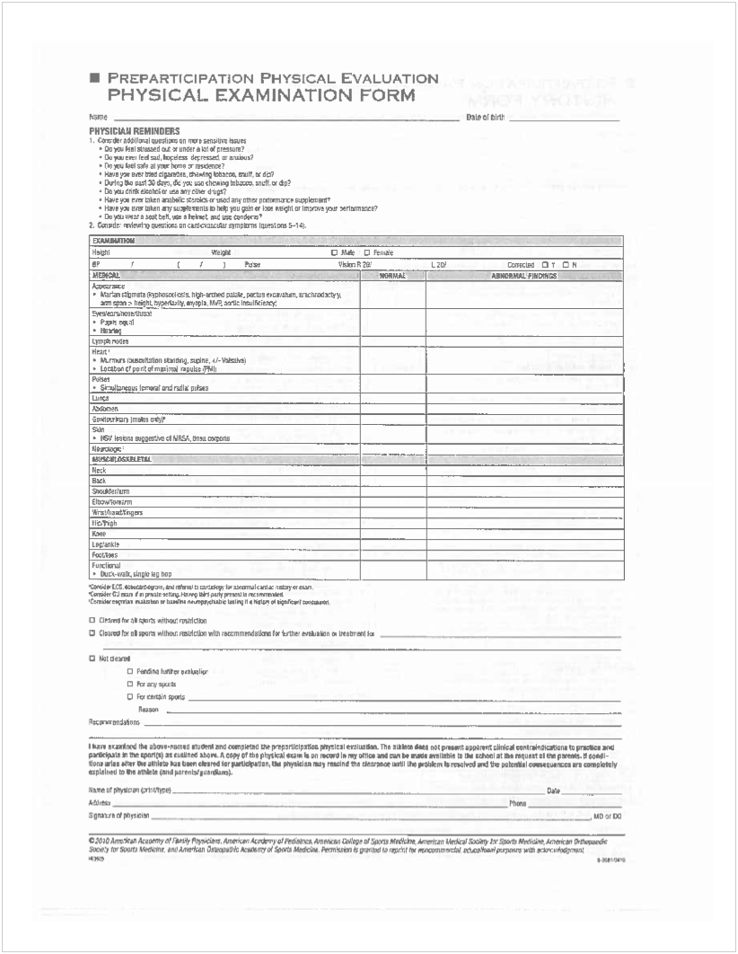
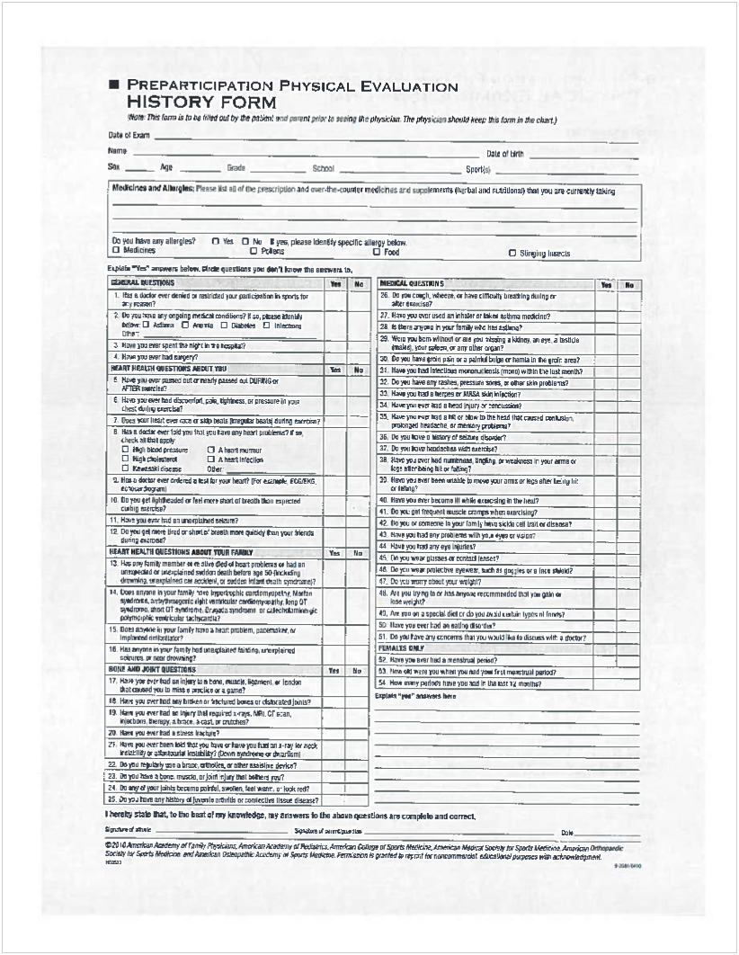
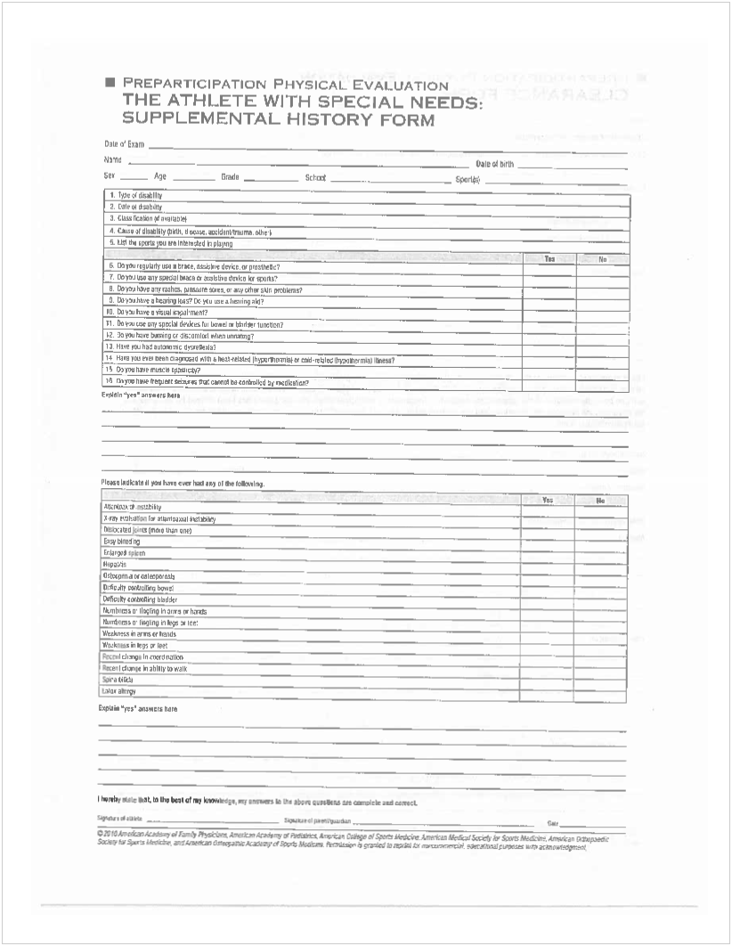
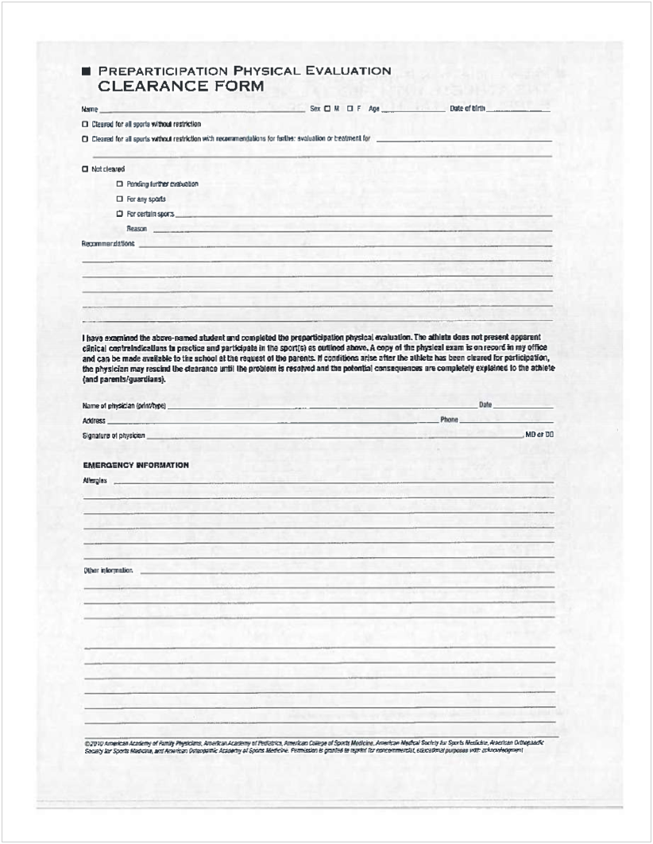
DRUG TEST CONSENT FORM

I hereby consent to have samples of my urine collected and tested to determine if certain drugs are present. I understand that urinalysis testing is required by Shawnee Community College's Athletic Department and is part of the approved policies governing the institution. The results of the said test will be kept confidential and can only be viewed by the Athletic Director, Head Coach of my sport, Assistant Coach, the Head Athletic Trainer, Dean of Students, and any administrator so designated by the College.

If results of the said test show a positive use of illegal drugs as determined by Shawnee Community College (reference Athletic Manual), steroids or alcohol or other controlled substances the athlete will have an opportunity to discuss the matter with the Athletic Director, Head Coach of my sport, Head Athletic Trainer, and the Dean of Students, and to present evidence of any rebuttal or mitigating circumstances which he or she feels necessary. Following this discussion, a decision concerning my participation in athletics at Shawnee CommunityCollege will be made at that time by the Athletic Director, Head Coach of my sport, Dean of Students, and the Head Athletic Trainer. The decision being one of the following:
- A probationary period with immediate loss of a scholarship for a designated period of time.
- Suspension from the team with immediate loss of your scholarship for the remainder of the school year.
- Sanctions issued by the Dean of Students.

Furthermore, if the results of the said test show a positive use of illegal drugs as determined by Shawnee Community College (reference Athletic Manual), steroids or alcohol or other controlled substance, that athlete or their specimen and are retested to assure the athlete continues to show negative use of illegal drugs, steroids, or alcohol has occurred. The cost of these tests will possibly be charged to the student.

You are gree to refuse to consent to drug testing under this program. However, upon declining participation in the testing program, which is designed to protect your health and reputation, you will not be eligible for a scholarship or to participate in any intercollegiate sport offered by Shawnee Community College. If you refuse to test for drugs as provided in this policy, after initially consenting, you shall be considered to have made a decision not to participate and will forfeit your scholarship immediately. I also acknowledge that I have been provided with a copy of Shawnee Community College's drug testing policy. I understand that under the Family EducationRight to Privacy Act (F.E.R.P.A), that Shawnee Community College officials will release alcohol and drug violations and results of drugs test to parents or legal guardians.

Shawnee Community College, its Board of Trustees, administrators, employees, and agents are herby released from any legal responsibility or liability as a result of their compliance.

Printed Name of Student-Athlete Signature of Student-Athlete Date

Printed Name of Parent/Guardian Signature of Parent/Guardian Date

ACKNOWLEDGMENT AND AGREEMENT TO ABIDE BY SHAWNEE COMMUNITY COLLEGE'S ATHLETIC PROCEDURE MANUAL

By my signature on this form, I acknowledge that I am aware of Shawnee Community's Athletics Procedure manual and furthermore, I agree to conform and abide by all provisions therein.

Signature of Student-Athlete Date Signed

